Zachery Wolfe

**16S MiSeq Results: Opportunistic *Stenotrophomonas* spp*.* colonizes the gut microbiome of insecticide-resistant German cockroach (*B. germanica*) after oral administration of antibiotics**

**Introduction**

Research has shown that the gut bacteria in some insect species break down xenobiotics and toxic compounds, facilitating and enhancing an insect’s ability to resist insecticidal compounds (de Almeida *et al.* 2017). The coffee berry borer (*Hypothenemus hampei*), a devastating pest to coffee plantations across the world, has gut microbes that have developed the ability to degrade the insecticidal compound caffeine (Ceja-Navarro *et al.* 2015). The apple maggot (*Rhagoletis pomonella*) contains a symbiotic bacterium (*Pseudomonas melophthora*) which can degrade up to six different insecticides that would otherwise control the apple maggot (Boush and Matsumura 1967).

The German cockroach (*Blattella germanica*) is an insect species notorious for its ability to tolerate insecticide applications and is also known to host a plethora of microbial gut symbionts (SOURCE, Wada-Katsumata *et al.* 2015). Isolating these microbial species and studying how they react to insecticidal compounds is crucial to determine the mechanisms of insecticide resistance in *B. germanica* and in its microbial symbionts. Learning which bacterial symbionts are present in insecticide-resistant and susceptible cockroaches will give us clues as to which bacterial symbionts might help degrade and detoxify insecticides.

The primary objective for this project is to compare the whole gut bacterial profiles of insecticide resistant and susceptible *B. germanica*. The hypothesis for my objective is that there will be differences in gut bacterial composition between insecticide resistant and susceptible cockroach strains.

**Methods**

*Insects*: Both insecticide-resistant and insecticide-susceptible strains of male German cockroaches will be obtained and tested for their ability to resist and detoxify insecticides. The insecticide-resistant strain of *B. germanica* is originally obtained from Danville, IL (Danville-R) and has shown field resistance to Indoxacarb, Abamectin and Fipronil (Fardisi *et al.* 2017). The insecticide-susceptible strain known as Johnson Wax susceptible (J-wax-S) is a standard susceptible lab strain and has no previous exposure to Indoxacarb, Abamectin or Fipronil (Fardisi *et al.* 2017).

*Rearing and preparation of traditionally raised insects (Gondhalekar and Scharf 2012)*: Rearing is conducted in 3.8 liter plastic containers which are held in a reach-in environmental chamber at 25 ± 1°C temperature and 12:12 hour light:dark photoperiod. The inner top portions of the rearing units are lightly coated with a mixture of petroleum jelly and mineral oil (2:3) to prevent the cockroaches from escaping. Each rearing unit contains corrugated cardboard harborages, a water source, and rodent diet (No. 8604; Harlan Teklad, Madison, WI).

*Treatment and subsequent gut extractions*: Roaches will be separated into four treatment groups: insecticide-resistant roaches treated with/without antibiotics and insecticide-susceptible treated with/without antibiotics. Treatments were held in groups of 10 male adult cockroaches per petri dish (each dish containing a single pellet (approx. 1g) of Purina kitten chow (number 100137; Nestlé Purina, Neenah, WI) along with 1.5 mL of either NanoPure water or Kanamycin-infused NanoPure water) for 72 hours before the gut extraction is conducted. Kanamycin, the antibiotic used in the experiment, is dissolved in 1.5 mL NanoPure water at 5% w/v (discuss preliminary bioassay). The control group received only 1.5 mL NanoPure water. The whole gut, including the bacteria inside of the gut, of these cockroaches has been extracted and homogenized in PBS.

*PCR and sequencing*: DNA was isolated from the homogenization of the gut and replicated using PCR. The gut, including the bacteria inside of the gut, of five roaches of each treatment type will be extracted and homogenized in PBS. DNA will be isolated from the homogenization of the gut. Bacterial 16S rDNA will be PCR-amplified using the previously published primers 338F (ACTCCTACGGGAGGCAGCAG) and 518R (ATTACCGCGGCTGCTGG) (Fierer *et al.* 2005). PCR will be carried out in a total volume of 15 μl. Each reaction will contain 7.5 μl of the Ssofast evagreen supermix reagent [water (50-100%), Proprietary Reagent RF I (10-20%), Proprietary Reagent TR 7 (5-10%), Proprietary Reagent J11 (1.0-2.5%), tris(hydroxymethyl)aminomethane (0.1-1.0%), Proprietary Reagent RS 1 (0.1-1.0%), potassium chloride (0.1-1.0%)], 0.5 μl each of the forward and reverse primers (stock 10 μM), 3 ng of template DNA, and nuclease-free water up to 15 μl. The Bio-Rad MyCycler thermocycler reaction conditions are: initial denaturation at 95 ºC for 3 min; 30 cycles of denaturation at 95 ºC for 15 s, annealing at 55 ºC for 15 s, and elongation at 72 ºC for 30 s; and a final elongation at 72 ºC for 5 min. An additional 5 cycle PCR (with the same conditions) will be performed to add barcodes to the resulting 30-cycle PCR product. To avoid PCR bias, the lowest DNA template quantity and the fewest possible PCR amplification cycles were chosen. The integrity and quantity of the amplicons will be verified by agarose gel (2%) electrophoresis. DNA concentration will be quantified on a nanodrop 2000c spectrophotometer (Thermo Fisher Scientific, Waltham, MA). Samples were sequenced using Illumina Mi-Seq at the Purdue Genomics Core Facility (Purdue University, West Lafayette, IN). The sample pool was titered using a KAPA Library Quantification Kit (Roche, Basel, Switzerland) and run as 5% of a MiSeq 500 cycle kit run (Illumina, San Diego, CA). Each strain of cockroaches (insecticide-resistant and susceptible) and each treatment type (with and without antibiotic treatment) will be replicated 3 times, for a total of 12 biological replications each containing 5 whole homogenized guts:

**Table 1.** Summary of 12 treatments sequenced.

|  |  |  |  |
| --- | --- | --- | --- |
| Danville Control (5 guts) | Danville kanamycin-treated (5 guts) | J-wax Control (5 guts) | J-wax kanamycin-treated (5 guts) |
| Danville Control (5 guts) | Danville kanamycin-treated (5 guts) | J-wax Control (5 guts) | J-wax kanamycin-treated (5 guts) |
| Danville Control (5 guts) | Danville kanamycin-treated (5 guts) | J-wax Control (5 guts) | J-wax kanamycin-treated (5 guts) |

The results of the sequence will determine the relative abundance of different bacterial taxa between insecticide-resistant and susceptible strains of *B. germanica*.

*Sequence filtering (Cui* et al. *2019)*: The sequences were processed using mothur v.1.39.3 (Schloss *et al*. 2009) following the MiSeq standard operating procedure (SOP) proposed by Kozich *et al*. Low-quality sequences were removed from the analysis if they contained ambiguous characters or were over 325 bp. After merging any duplicates, the pre-cluster method was applied to further reduce the sequencing errors produced by the MiSeq Illumina sequencing platform. Chimeras were identified and removed using chimera.vsearch and remove.seqs, respectively. The Silva database (version 138) was used to align and classify the sequences. The sequences were clustered into OTUs at a distance threshold of 0.03 using the average neighbor method. The sequences were sampled to a depth of 24390

*Statistical analysis (Cui* et al. *2019)*: The sequences were subsampled to a depth of 24390 as this was the number of sequences in the sample with the fewest sequences present. Alpha-diversity and species evenness were estimated using the Shannon diversity index and the inverse of Simpson’s evenness index, respectively. All diversity indices were calculated with mothur v. 1.39.3. The differences in indices among bacteria present in Danville, J-Wax, Kanamycin-treated and control samples were analyzed by one-way ANOVA followed by Tukey’s test. NMDS and perMANOVA were performed using the Vegan package in R (Oksanen *et al.* 2013) to compare and evaluate differences between bacterial communities in the two strains and two treatment types. Barplots of phylum and genuses present in each sample were constructed, along with a heatmap containing the 20 most abundant genuses in each sample to compare how the bacterial community varies between treatments.

**Results**

*Alpha diversity*:

**Figure 1.** Alpha diversity (left: Shannon, right: Inverse Simpson) categorized by treatment

Cockroach guts treated with kanamycin were less diverse than cockroach guts in the control group, suggesting that kanamycin eliminated a wide variety of bacterial taxa from the whole gut during the 72-hour treatment window before gut extraction.

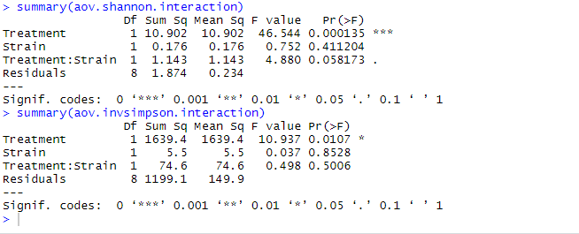

Antibiotic treatment had a significant effect on microbial diversity in both Danville and J-wax guts (p-values: Shannon: 0.000135, inverse Simpson: 0.0107). There are not significant differences in gut microbial diversity between the Danville and J-wax cockroach strains when treatment is not considered (p-values: Shannon: 0.411204, inverse Simpson: 0.8528). The p-values for combined Treatment:Strain interaction are 0.058173 and 0.5006 for Shannon and inverse Simpson’s diversity, respectively.

*Beta diversity*:

**Figure 2.** NMDS of beta-diversity (left: Bray-Curtis, right: Jaccard) categorized by treatment

Bacterial communities were unique to each treatment type in terms of their taxonomic diversities.

*Differential abundance by treatment:*

**Figure 3.** Top 5 genuses present throughout the entire sequence categorized by treatment and replication

**Figure 4.** Top 10 phyla present throughout the entire sequence categorized by treatment and replication

**Figures 5 & 6.** Phyla (5) and Genuses (6) present in relative abundance over 1% throughout the entire sequence categorized by treatment and replication.

When the Danville strain was fed antibiotics, *Stenotrophomonas* spp. was substantially greater in abundance than all other genuses combined. In addition to an increase in *Stenotrophomonas*, kanamycin exposure effectively decreased the quantities of all other bacterial genuses except for *Dysgonomonas* and a select group of unclassified *Bacteriodales* spp.

**Figure 7.** Heat map of top 20 genuses throughout the entire sequence categorized by treatment and replication. Gray = absent.

While quantities of each genus might vary by treatment type and even by replication within the same treatment type, most taxa are retained between each strain. As expected, there are on average more reads in the control roach guts compared to the kanamycin-treated roach guts, further suggesting that kanamycin eliminated a large portion of the microbiome.

*Differential abundance by DESeq2*:

**Figure 8.** Differential abundance between treatment types (control vs kanamycin) colored by phylum and labeled by genus. Positive log2FoldChange values indicate the presence of a genus is more indicative of a control treatment, whereas negative log2FoldChange values indicate the presence of a genus is more indicative of a kanamycin (antibiotic) treatment.

A select group of genuses belonging to the *Proteobacteria* phylum, in addition to some unknown *Bacteroidota* taxa, increased in quantity once the microbiome was exposed to kanamycin. Most other bacterial taxa decreased in quantity after kanamycin exposure.

*Random forest analysis*:

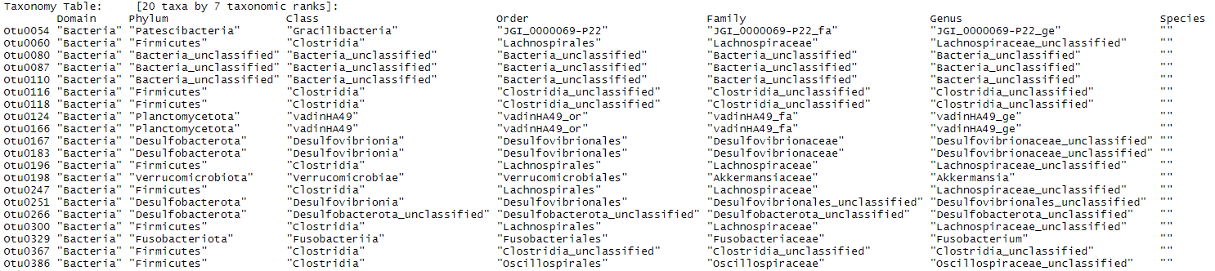

**Figure 9.** Bar chart and list of 20 most important OTUs for classifying between antibiotic (kanamycin) and control treatments

The *Gracilibacteria* bacterium JGI 0000069-P22 was the most important OTU in terms of classifying between our kanamycin and control treatments. This is followed by some *Firmicutes* and an unclassified bacterium. JGI 0000069-P22 is more abundant in kanamycin-treated samples, whereas the *Firmicutes* and unclassified bacterium were more abundant in the control samples.

**Discussion**

The discovery of such a wide variety of undescribed bacterial taxa is exciting but also presents challenges of its own. We have little knowledge of many of the most critical genuses classifying between the treatment types used in the experiment; needless to say, it is possible that these unique bacteria are synergists to the cockroach host and might provide niche benefits, especially in terms of xenobiotic detoxification. Since there is very little current research on the gut microbiome of German cockroach, more studies on metabolism and degradation are needed before we can determine specific relationships these microbes might have with their host, or perhaps each other.

*Diversity*: Antibiotic treatment had a significant effect on alpha diversity in both the Danville and J-wax population. The Danville and J-wax cockroach strains don’t have significant differences in gut bacterial taxa when treatment is not considered, while combined treatment and strain interaction yielded a significance value of 0.058173 and 0.5006 for Shannon and inverse Simpson’s diversity, respectively. While technically not significant within a 95% confidence interval, the combined effects of treatment and strain were still somewhat indicative of the gut microbiota present in the guts.

*Abundance*: While the presence of *Dysgonomonas* and *Alistipes* spp. were higher in the Danville strain, they are nonetheless present to a reduced extent in the guts of J-wax roaches as well. It is possible that there are further differences between the two strains at the species level.

*Taxa of interest*: *Stenotrophomonas* spp. are present in every sequence sample to a certain extent, but no more so than in the Danville resistant cockroaches that were fed kanamycin. *Stenotrophomonas* is a genus known for its ability to detoxify xenobiotics and break down complex organic molecules (Ryan *et al.* 2009), which might allow a strain of insecticide resistant German cockroaches to tolerate higher doses of insecticides. Also, many *Stenotrophomonas* spp. have a high level of intrinsic resistance to antibiotics (Ryan *et al.* 2009) which could also explain why it was able to completely overtake the gut microbiome once kanamycin was introduced; kanamycin was less effective at controlling *Stenotrophomonas* compared to other bacterial genuses. Introducing a disturbance (in this case, an antibiotic) to the microbiome allowed for drastically tolerant *Stenotrophomonas* bacteria to take advantage of resources in the gut without competition from other microorganisms.

The family *Lachnospiraceae* contains anaerobic bacteria that are usually isolated from the gastrointestinal tract of animals (Cotta and Forster 2006). These bacteria are motile, curved rods, and usually stain Gram negative or weakly Gram positive (Cotta and Forster 2006). Members of *Lachnospiraceae* have been linked to obesity and protection from colon cancer in humans, mainly due to the association of many species with the production of butyric acid, a substance that is important for both microbial and host epithelial cell growth (Meehan and Beiko 2014).

*Firmicutes* was among the phyla most sensitive to kanamycin exposure. *Firmicutes* is widely diverse and has been studied in both human and animal gut microbiology, especially in its links to obesity (Ley *et al.* 2006, Guo *et al.* 2008). Many of these firmicutes are in class Clostridia, a common digestive tract bacterium consisting of only anaerobes (Wells and Wilkins 1996). Research on the Turkestan cockroach (*Shelfordella lateralis*) suggests that both gut tissue and microbiota contribute to oxygen consumption and suggest that oxygen status in the gut influences microbial colonization success (Tegtmeier *et al.* 2016).

*Blattabacterium* spp present in these sequences likely came from fat bodies outside of the digestive tract (Sabree *et al.* 2009, López-Sánchez *et al.* 2009) and is a contaminant to our whole gut sample. However, the fact that orally ingested kanamycin effectively controlled *Blattabacterium* symbionts in the fat bodies of the insecticide resistant Danville strain is noteworthy as insecticide researchers could consider host control methods targeted at disrupting the symbiosis between *Blattabacterium* and the host cockroach.

*Comparison to previous studies*: Ana Elena Pérez-Cobas and her colleagues pyrosequenced the hypervariable regions V1–V3 of the 16S rRNA gene of the whole bacterial community of German cockroach when exposed to different diets in 2015.

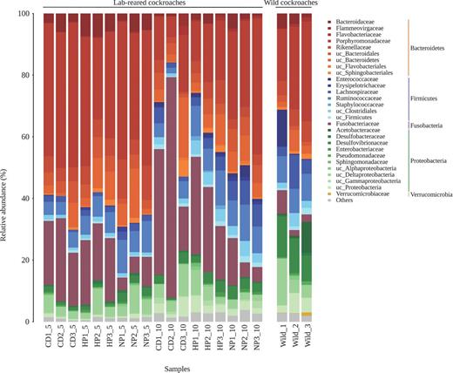

**Figure 10.** Pérez-Cobas *et al.* 2015 pyrosequence results: Three diets differing in the protein content (0, 24 and 50%; NP (no protein), CD (control diet), HP (high protein)) were tested at two time points in lab-reared individuals. In addition, the gut microbiota of wild adult cockroaches was also analyzed.

Jose Pietri *et al.* published a manuscript in 2018 in which whole guts from untreated German cockroaches, or cockroaches continuously exposed to 0.5% doxycycline (another antibiotic) for 4 days were dissected and DNA was isolated sequencing of bacterial 16S rRNA genes.

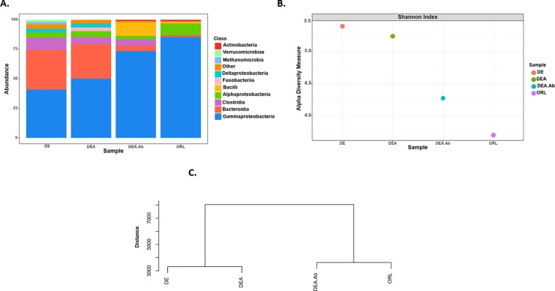

**Figure 11.** Pietri *et al.* 2018 demonstrating that gut microbiota differs between insecticide-resistant (DE, DEA), antibiotic-treated (DEA_Ab) and insecticide-susceptible (ORL) German cockroaches.

Madhavi Kakumanu and colleagues of Coby Schal at North Carolina State University also sequenced the whole body, whole guts and feces of German cockroaches in 2018.

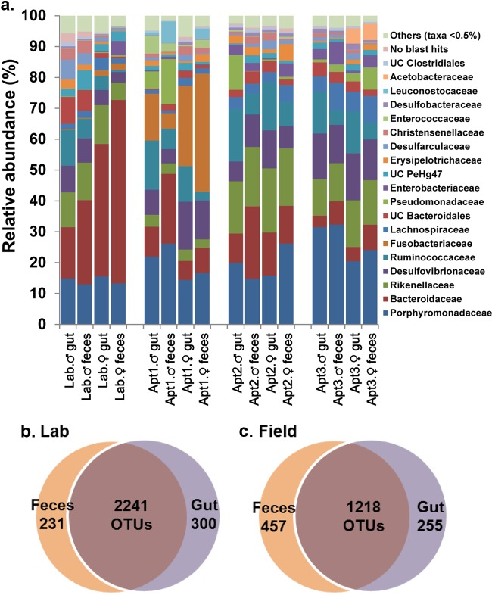

**Figure 12.** Kakumanu *et al.* 2018 demonstrating that gut microbiota differs between lab-raised and field collected German cockroaches.

This research corroborates that the oral administration of an antibiotic effectively reduces species diversity in German cockroach. Additionally, these researchers found that relative abundances of bacterial taxa in the gut can vary drastically from individual to individual, location to location, and even among individuals in a laboratory environment kept under different dietary regimes (Pérez-Cobas *et al.* 2015, Kakumanu *et al.* 2018, Pietri *et al.* 2018). We used the same primers to amplify the V4 region as Kakumanu *et al.* and observed some of the same families in both of our sequences. While previous literature supports many of our observations, it varies with our current findings in many other ways. For instance, Pérez-Cobas *et al.* used pyrosequencing to sequence the V1-V3 region instead of MiSeq to sequence the V4 region, as Illumina’s platforms were not as popular during the time of publication. Additionally, a different antibiotic was used (doxycycline) and the bacterial taxa sequenced differ when comparing Pietri’s DE (Destin, FL – Resistant) and ORL (Orlando, FL – Susceptible) to our Dan (Danville, IL – Resistant) and J-wax (Susceptible) strains. Unfortunately, there is also no information on how gut microbiota shift once the ORL – Susceptible cockroaches have been fed antibiotics. However, the largest limitation of our current research is that many of our reads yielded undescribed species, which reduces our ability to compare our research with past studies and sequences.

**Conclusions**

*Stenotrophomonas* spp. can colonize a gut microbiome with limited other symbionts in the presence of kanamycin. The mechanisms of antibiotic resistance, as well as potential insecticide degradation and metabolism should be investigated further in this genus. The gut microbiomes of Danville-R and J-wax-S German cockroaches are not significantly different on their own, but the introduction of orally ingested kanamycin eliminates certain taxa while increasing the concentration of others. More research is needed to determine the phylogenetic classifications of undescribed species discovered in the sequence, as well as their functions, structures, and relationships to the German cockroach host.

**References**

Boush, M. G., & Matsumura, F. (1967). Insecticidal degradation by Pseudomonas melophthora, the bacterial symbiote of the apple maggot. Journal of Economic Entomology, 60(4), 918-920.

Ceja-Navarro, J. A., Vega, F. E., Karaoz, U., Hao, Z., Jenkins, S., Lim, H. C., ... & Brodie, E. L. (2015). Gut microbiota mediate caffeine detoxification in the primary insect pest of coffee. Nature communications, 6, 7618.

Cotta, M., & Forster, R. (2006). The family Lachnospiraceae, including the genera Butyrivibrio, Lachnospira and Roseburia. *The prokaryotes: a handbook on the biology of bacteria: Bacteria: Firmicutes, Cyanobacteria*.

Cui, Y., Chun, S. J., Baek, S. H., Lee, M., Kim, Y., Lee, H. G., ... & Oh, H. M. (2019). The water depth-dependent co-occurrence patterns of marine bacteria in shallow and dynamic Southern Coast, Korea. *Scientific reports*, *9*(1), 1-13.

De Almeida, L. G., de Moraes, L. A. B., Trigo, J. R., Omoto, C., & Cônsoli, F. L. (2017). The gut microbiota of insecticide-resistant insects houses insecticide-degrading bacteria: A potential source for biotechnological exploitation. PLoS ONE, 12(3), e0174754.

Fardisi, M., Gondhalekar, A. D., & Scharf, M. E. (2017). Development of Diagnostic Insecticide Concentrations and Assessment of Insecticide Susceptibility in German Cockroach (Dictyoptera: Blattellidae) Field Strains Collected from Public Housing. Journal of Economic Entomology, 110(3), 1210-1217.

Fierer, N., Jackson, J. A., Vilgalys, R., & Jackson, R. B. (2005). Assessment of soil microbial community structure by use of taxon-specific quantitative PCR assays. *Appl. Environ. Microbiol.*, *71*(7), 4117-4120.

Gondhalekar, A. D., & Scharf, M. E. (2012). Mechanisms underlying fipronil resistance in a multiresistant field strain of the German cockroach (Blattodea: Blattellidae). Journal of medical entomology, 49(1), 122-131.

Kakumanu, M. L., Maritz, J. M., Carlton, J. M., & Schal, C. (2018). Overlapping community compositions of gut and fecal microbiomes in lab-reared and field-collected German cockroaches. *Applied and environmental microbiology*, *84*(17).

Kozich, J. J., Westcott, S. L., Baxter, N. T., Highlander, S. K., & Schloss, P. D. (2013). Development of a dual-index sequencing strategy and curation pipeline for analyzing amplicon sequence data on the MiSeq Illumina sequencing platform. *Appl. Environ. Microbiol.*, *79*(17), 5112-5120.

Ley, R. E., Turnbaugh, P. J., Klein, S., & Gordon, J. I. (2006). Human gut microbes associated with obesity. *nature*, *444*(7122), 1022-1023.

López-Sánchez, M. J., Neef, A., Peretó, J., Patiño-Navarrete, R., Pignatelli, M., Latorre, A., & Moya, A. (2009). Evolutionary convergence and nitrogen metabolism in Blattabacterium strain Bge, primary endosymbiont of the cockroach Blattella germanica. *PLoS genetics*, *5*(11).

Meehan, C. J., & Beiko, R. G. (2014). A phylogenomic view of ecological specialization in the Lachnospiraceae, a family of digestive tract-associated bacteria. *Genome biology and evolution*, *6*(3), 703-713.

Oksanen, J., Blanchet, F. G., Kindt, R., Legendre, P., Minchin, P. R., O’hara, R. B., ... & Oksanen, M. J. (2013). Package ‘vegan’. *Community ecology package, version*, *2*(9), 1-295.

Pérez-Cobas, A. E., Maiques, E., Angelova, A., Carrasco, P., Moya, A., & Latorre, A. (2015). Diet shapes the gut microbiota of the omnivorous cockroach Blattella germanica. *FEMS microbiology ecology*, *91*(4), fiv022.

Pietri, J. E., Tiffany, C., & Liang, D. (2018). Disruption of the microbiota affects physiological and evolutionary aspects of insecticide resistance in the German cockroach, an important urban pest. *PloS one*, *13*(12).

Ryan, R. P., Monchy, S., Cardinale, M., Taghavi, S., Crossman, L., Avison, M. B., ... & Dow, J. M. (2009). The versatility and adaptation of bacteria from the genus Stenotrophomonas. *Nature Reviews Microbiology*, *7*(7), 514-525.

Sabree, Z. L., Kambhampati, S., & Moran, N. A. (2009). Nitrogen recycling and nutritional provisioning by Blattabacterium, the cockroach endosymbiont. *Proceedings of the National Academy of Sciences*, *106*(46), 19521-19526.

Schloss, P. D., Westcott, S. L., Ryabin, T., Hall, J. R., Hartmann, M., Hollister, E. B., ... & Sahl, J. W. (2009). Introducing mothur: open-source, platform-independent, community-supported software for describing and comparing microbial communities. *Appl. Environ. Microbiol.*, *75*(23), 7537-7541.

Tegtmeier, D., Thompson, C. L., Schauer, C., & Brune, A. (2016). Oxygen affects gut bacterial colonization and metabolic activities in a gnotobiotic cockroach model. *Appl. Environ. Microbiol.*, *82*(4), 1080-1089.

Wada-Katsumata, A., Zurek, L., Nalyanya, G., Roelofs, W., Zhang, A., & Schal, C. (2015). Gut bacteria mediate aggregation in the German cockroach. *Proceedings of the National Academy of Sciences of the United States of America.,* *112*(51), 15678-15683.

Wells, C. L., & Wilkins, T. D. (1996). Clostridia: sporeforming anaerobic bacilli. In *Medical Microbiology. 4th edition*. University of Texas Medical Branch at Galveston.